# **References**

Emadamerho-Atori, N., 2025. *CSS Text Animations: 40 Creative Examples to Try.* [Online]   
Available at: https://prismic.io/blog/css-text-animations  
[Accessed 14 March 2025].

Exclusive Books, 2025. *Things Fall Apart Chinua Achebe.* [Online]   
Available at: https://exclusivebooks.co.za/products/9780141023380?_pos=1&_sid=157bc9b4a&_ss=r  
[Accessed 7 March 2025].

Eygi, C., 2025. *Media Query CSS Tutorial – Standard Resolutions, CSS Breakpoints, and Target Phone Sizes.* [Online]   
Available at: https://www.freecodecamp.org/news/css-media-queries-breakpoints-media-types-standard-resolutions-and-more/  
[Accessed 28 March 2025].

GeeksforGeeks, 2024. *How to Target Specific Screen Sizes or Devices with CSS ?.* [Online]   
Available at: https://www.geeksforgeeks.org/how-to-target-specific-screen-sizes-or-devices-with-css/  
[Accessed 28 March 2025].

HostingerTutorials, 2025. *25 Examples of eCommerce Websites With Fantastic Designs for 2025.* [Online]   
Available at: https://www.hostinger.com/tutorials/ecommerce-website-examples#19_Notebook_Therapy  
[Accessed 14 March 2025].

mdn_, 2025. *CSS: Cascading Style Sheets.* [Online]   
Available at: https://developer.mozilla.org/en-US/docs/Web/CSS  
[Accessed 14 March 2025].

W3 Schools, 2025. *CSS Styling Images.* [Online]   
Available at: https://www.w3schools.com/css/css3_images.asp  
[Accessed 14 Month 2025].

WIX, 2025. *5 web design tips for an outstanding site.* [Online]   
Available at: https://www.wix.com/blog/5-design-tips-for-a-professional-site  
[Accessed 14 Month 2025].

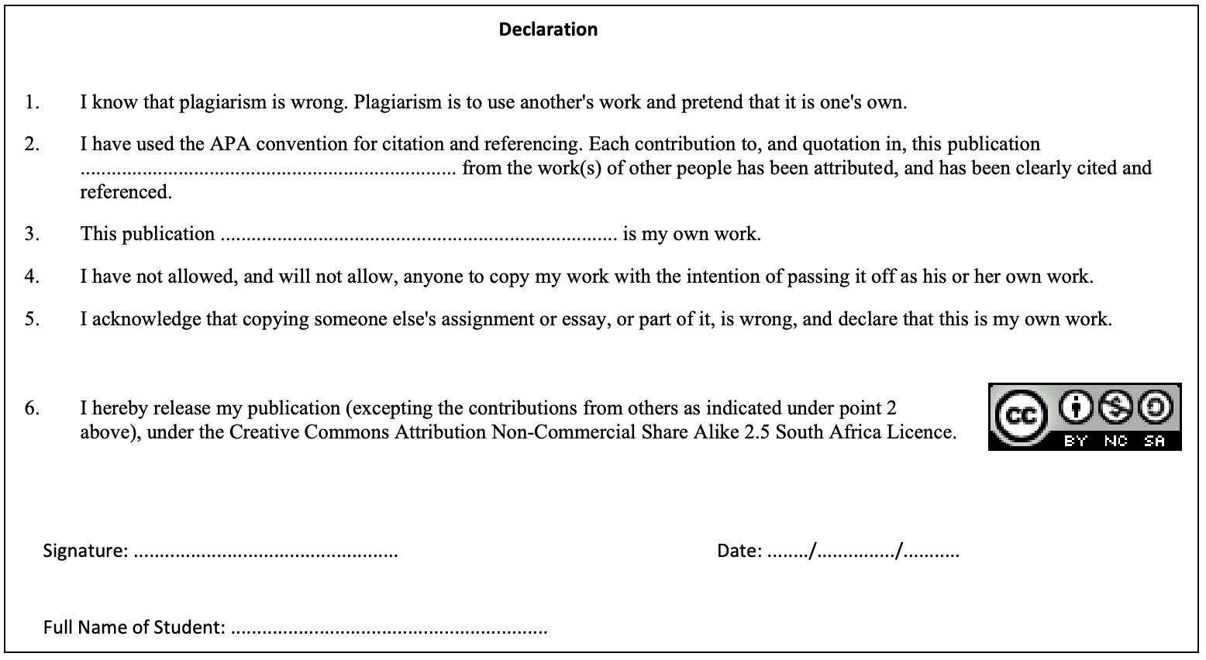

***Signature:*** *A. Nkhi*

***Name:*** *Amukelani Nkhi*

***Date:*** *28/03/2025*

***Referencing Convention:*** *Harvard*